

**Campus:** Beqaa

**Faculty:** Arts and Sciences

**Instructor:** Garo Pilawjian  
**Course:** CSCI335 – Fall 2021-2022

Crime Reporting System

# Students

Amr Sami Hammoud

**ID:** 22030136

Mohammad Abdul Muti Farah

**ID:** 22030156

Mohamad Jamal Abdelkhalek

**ID:** 22031045

Mosaab Omar Hassan

**ID:** 22030379

# Intro

The crime reporting system is created to help the society and the policemen in arresting criminals through reports against a crime. Which is sent by residents to the nearest police station, to start in its turn a response action against the criminal. This database was created to record the whole process from the resident’s report till the criminal’s arrest containing all the details.

# Project Steps

1. Project context analysis.
2. Converting context into ER-diagram.
3. Converting ER-diagram into relational model diagram.
4. Creating a database.
5. Units-testing on database .

## NOTE

All project files (requirements,ER,SQL queries,data guide) are available for download from the project’s Github repository. Click [HERE](https://github.com/amr-hammoud/crime-reporting-system) to access it.

## Context Analysis

In this step we read the context of the project carefully, then we extracted 5 nouns and 6 verbs from it. That means 5 entities and 6 relations in the language of ER-diagram. Also, we extracted the attributes of each entity from the detailed requirements.

## ER-Diagram

We converted the nouns and the verbs into 5 rectangles and 6 rhombuses and many ellipses. Each ellipse represents an attribute of an entity. Then we connected the attributes with their entities, and the entities with each other by relations to get a logical ER-Diagram. Which is the main rock for building databases.

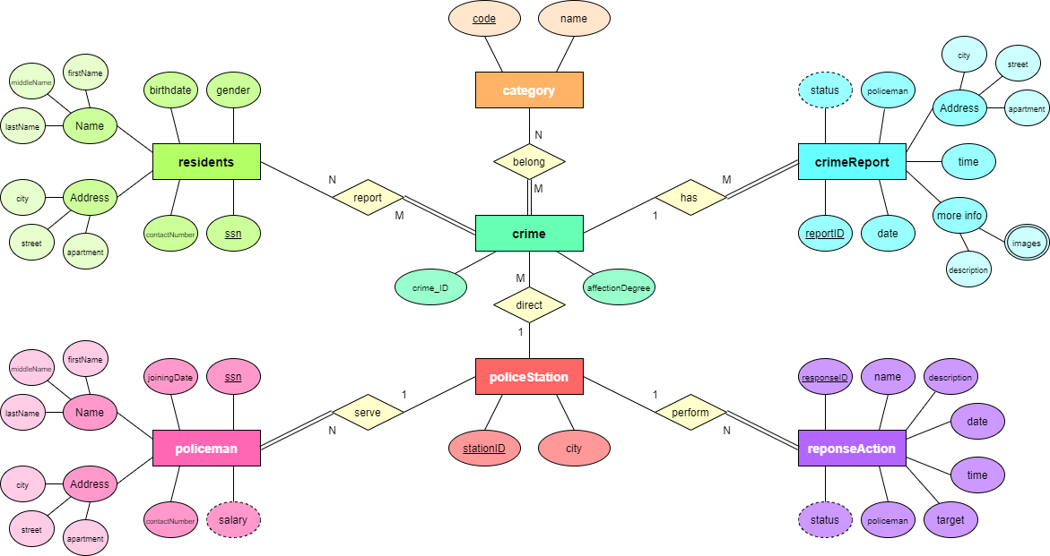

* Residents report a crime through a crime report
* Each crime belongs to a category
* Each crime is directed by a police station
* The police station performs one or many response action(s)
* Response action(s) are done by policemen who serve in the police station

## Relational Model

We converted the relations and entities of the ER-diagram into a relational model depending on the rules of this process. Then we determined the primary key and the foreign key of each. Also, we arranged them one by one from the top to bottom depending on the number of foregin keys at each table. This arrangement helps us create and insert data without errors.

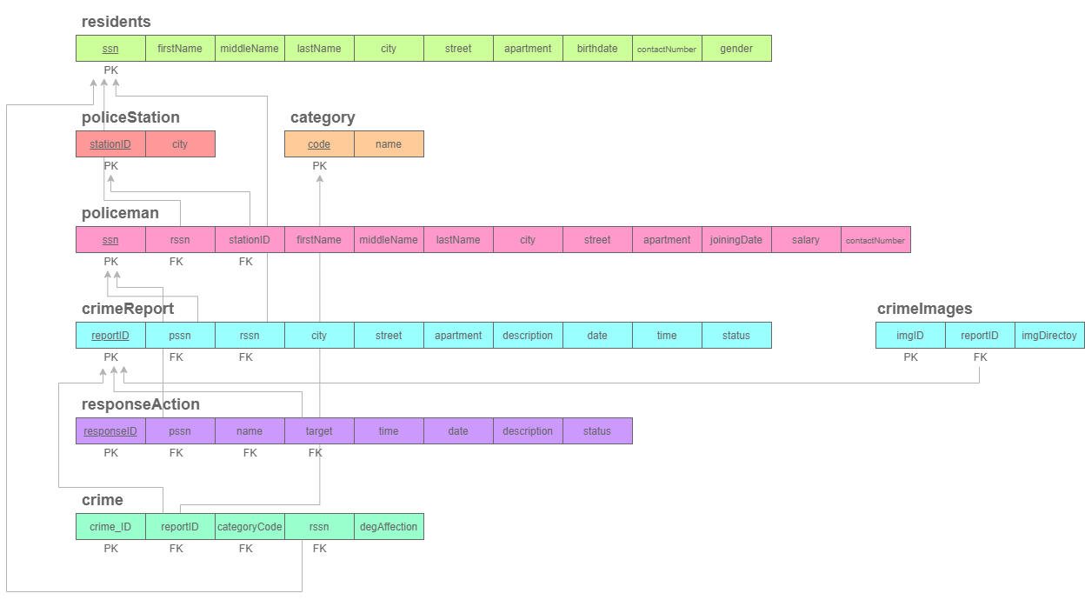

## Creating SQL database

We created two SQL files:

### Database & Tables

In the first file we created the database and the tables depending on the relational model diagram. We added primary and foreign keys to each table.

CREATE DATABASE Crime_Reporting_System;

CREATE TABLE residents(

ssn char(10),

firstName varchar(20) NOT NULL,

middleName varchar(20) NOT NULL,

lastName varchar(20) NOT NULL,

city varchar(25) NOT NULL,

street varchar(25),

apartment int,

birthdate date,

contactNumber int NOT NULL,

gender char(1),

PRIMARY KEY(ssn));

CREATE TABLE policeStation(

stationID char(3),

city varchar(25) NOT NULL,

PRIMARY KEY(stationID));

CREATE TABLE category(

code char(3),

name varchar(30) NOT NULL,

PRIMARY KEY(code));

CREATE TABLE policeman(

ssn char(9),

rssn char(10),

stationID char(3) NOT NULL,

firstName varchar(20) NOT NULL,

middleName varchar(20) NOT NULL,

lastName varchar(20) NOT NULL,

city varchar(25) NOT NULL,

street varchar(25),

apartment int,

joiningDate date,

salary int,

contactNumber int NOT NULL,

PRIMARY KEY (ssn));

CREATE TABLE crimeReport(

reportID char(10),

pssn char(9) NOT NULL,

rssn char(10) NOT NULL,

city varchar(25) NOT NULL,

street varchar(25),

apartment int,

description varchar(max) NOT NULL,

date date NOT NULL,

time time NOT NULL,

status varchar(max) NOT NULL,

PRIMARY KEY (reportID));

CREATE TABLE crimeImages(

imageID char(12),

reportID char(10) NOT NULL,

imgDirectory varchar(max) NOT NULL,

PRIMARY KEY (imageID));

CREATE TABLE responseAction(

responseID char(8),

pssn char(9) NOT NULL,

name varchar(40),

time time NOT NULL,

date date NOT NULL,

description varchar(max) NOT NULL,

target char(10) NOT NULL,

status varchar(max),

PRIMARY KEY (responseID));

CREATE TABLE crime(

crimeID char(11) NOT NULL,

reportID char(10) NOT NULL,

categoryCode char(3) NOT NULL,

rssn char(10) NOT NULL,

degAffection varchar(max));

--Foreign Keys

ALTER TABLE policeman ADD FOREIGN KEY (stationID) REFERENCES policeStation(stationID) ON DELETE CASCADE ON UPDATE CASCADE;

ALTER TABLE crimeReport ADD FOREIGN KEY (pssn) REFERENCES policeman(ssn) ON DELETE CASCADE ON UPDATE CASCADE;

ALTER TABLE crimeReport ADD FOREIGN KEY (rssn) REFERENCES residents(ssn) ON DELETE CASCADE ON UPDATE CASCADE;

ALTER TABLE crimeImages ADD FOREIGN KEY (reportID) REFERENCES crimeReport(reportID) ON DELETE CASCADE ON UPDATE CASCADE;

ALTER TABLE responseAction ADD FOREIGN KEY (pssn) REFERENCES policeman(ssn) ON DELETE CASCADE ON UPDATE CASCADE;

ALTER TABLE responseAction ADD FOREIGN KEY (target) REFERENCES crimeReport(reportID);

ALTER TABLE crime ADD FOREIGN KEY (reportID) REFERENCES crimeReport(reportID) ON DELETE CASCADE ON UPDATE CASCADE;

ALTER TABLE crime ADD FOREIGN KEY (categoryCode) REFERENCES category(code) ON DELETE CASCADE ON UPDATE CASCADE;

ALTER TABLE crime ADD FOREIGN KEY (rssn) REFERENCES residents(ssn);

### Data Insertion

In the second file we inserted logical data into the database.

INSERT INTO residents (ssn,firstName,middleName,lastName,city,street,apartment,birthdate,contactNumber,gender)

VALUES ('3111203764','Mohammad' ,'Youssef','Azzam','Beirut','Ain Al Mraiseh','7','1996-02-12','81876037','M'),

('3110017318','Dima','Ahmad','Al Hasan','Beirut','Ain Al Mraiseh','9','2000-04-01','81934489','F'),

('3110013541','Tarek','Anas','Rahbani','Beirut','Ain Al Mraiseh','15','2016-08-15','70158123','M'),

('3120126981','Ibrahim','Hasan','Itani','Beirut','Hamra','93','1999-11-12','71124086','M'),

('3120965367','Rana','Jamil','Harb','Beirut','Hamra','41','1934-05-26','78957216','F'),

('3121678247','William','Georges','Saliba','Beirut','Hamra','29','1983-09-18','81158610','M'),

('4710011982','Mona','Suleiman','Khalil','Zahle','Maalaka' ,'19','1998-12-29','78672445','F'),

('4710112436','Andrew','Youssef','Saliba','Zahle','Maalaka' ,'5','1986-11-04','81876255','M'),

('4710076974','Tony','Issa','Takomijian','Zahle','Maalaka' ,'20','2004-05-31','03555558','M'),

('4720182689','Ayman','Jad','Maadaranni','Zahle','Wadi Al Arayech','18','2002-10-19','03124865','M'),

('4720082391','Mansour','Elias','Farah','Zahle','Wadi Al Arayech','14','2000-01-01','03157914','M'),

('4720105890','Fatima','Mahmoud','Wehbi','Zahle','Wadi Al Arayech','74','1971-03-26','71195614','F'),

('7310106362','Ghada','Mostafa','Asaad','Tripoli','Bohssas','12','1994-06-03','78194760','F'),

('7310481702','Ahmad','Salim','Othman','Tripoli','Bohssas','51','1978-05-25','81175691','M'),

('7310812657','Mariam','Saleh','Shaaban','Tripoli','Bohssas','34','1949-02-18','81981765','F'),

('7320219183','Ibrahim','Hamed','Barakat','Tripoli','Mina','26','1998-12-29','71197256','M'),

('7320219348','Tony','Melhem','Rizk','Tripoli','Mina','19','2001-10-19','70124978','M'),

('7310613751','Huda','Sami','Othman','Tripoli','Mina','62','2009-09-18','70192475','F'),

('8610130638','George','Toufik ','Boustany','Tyre','Abbasiyye','14','1987-08-15','03944834','M'),

('8610101238','Ali' ,'Mahmoud','Habash','Tyre','Abbasiyye','11','1999-01-09','70927842','F'),

('8610008641','Rama','Ali','Zaiter','Tyre','Abbasiyye','15','1945-05-26','70124961','F'),

('8620099173','Hadi','Yahya','Taleb','Tyre','Borj El Chamali','67','1968-08-09','71197451','M'),

('8610012387','Sara','Hasan','Shamas','Tyre','Borj El Chamali','47','2006-11-16','81917541','F'),

('8610012865','Rami','Saed','Al Sayyed','Tyre','Borj El Chamali','94','1993-10-15','03715841','M');

INSERT INTO policestation

(stationID,city)

VALUES ('312','Beirut'),

('471','Zahle'),

('733','Tripoli'),

('862','Tyre');

INSERT INTO category

(code,name)

VALUES ('235','Drug trafficking'),

('547','Murder'),

('554','Kidnapping'),

('603','Identity Theft'),

('605','Blackmailing'),

('201','Robbery'),

('653','Ransomware');

INSERT INTO policeman (ssn,rssn,stationID,firstName,middleName,lastName,city,street,apartment,joiningDate,salary,contactNumber)

VALUES ('312196531','3111203764','312','Mohammad' ,'Youssef','Azzam','Beirut','Ain Al Mraiseh','7','2019-07-10','1600','81876037'),

('312042345','3121678247','312','William','Georges','Saliba','Beirut','Hamra','29','2004-04-15','2100','81158610'),

('312074327','4710112621','312','Mamdouh','Shamdeen','Araji','Zahle','Maalaka' ,'37','2007-07-11','1100','81762457'),

('471106411','4710112436','471','Andrew','Youssef','Saliba','Zahle','Maalaka' ,'5','2010-10-04','1200','81876255'),

('471191532','4720082391','471','Mansour','Elias','Farah','Zahle','Wadi Al Arayech','14','2019-07-26','1000','03157914'),

('471106432','4710115181','471','Andrew','Yousef','Saliba','Zahle','Maalaka' ,'5','2010-10-12','1500','81876255'),

('733134562','7310106362','733','Ghada','Mostafa','Asaad','Tripoli','Bohssas','12','2013-01-29','1400','78194760'),

('733191987','7320219348','733','Tony','Melhem','Rizk','Tripoli','Mina','19','2019-07-15','800','70124978'),

('733923456','3111201576','733','Hasan','Ali','Hawa','Beirut','Ain Al Mraiseh','63','1992-04-22','1500','71457488'),

('862198126','8610101238','862','Ali' ,'Mahmoud','Habash','Tyre','Abbasiyye','11','2019-07-05','1000','70927842'),

('862136349','8610012865','862','Rami','Saed','Al Sayyed','Tyre','Borj El Chamali','94','2013-01-06','1350','03715841'),

('862136824','3121247890','862','George','Toufik' ,'Boustany','Beirut','Hamra','14','2013-01-08','1600','03944834');

INSERT INTO crimeReport (reportID,pssn,rssn,city,street,apartment,description,date,time,status)

VALUES

('3121901271','312196531','4710011982','Beirut','Ain Al Mraiseh','56','Resident 4710011982 (Mona Khalil) reported that she saw 2 corpses filled with blood near her friends house','2019-03-14','23:12','Investigation Closed'),

('3122003718','312042345','3110017318','Beirut','Hamra','9','Resident 3110017318 (Dima Al Hasan) received a message from the bank informing her that 9623$ were deducted from her account due to purchases done at amazon store.','2020-05-24','13:27','Case under Investigation'),

('3122009431','312042345','3120965367','Beirut','Hamra','41','Resident 3120965367 (Rana harb) reported that her daughter is missing since 2 days. ','2020-06-28','09:08','Investigation Closed'),

('4711906530','471106432','4710112436','Zahle','Wadi Al Arayech','20','28kg of Cocaine were caught at Al Masnaa border checkpoint','2019-10-17','23:14','Investigation Pending Outcome'),

('4711903127','471191532','4720105890','Zahle','Wadi Al Arayech','74','LIU reported a ransomware attack on its database','2019-01-02','07:30','Investigation Closed'),

('7331901387','733134562','7310812657','Tripoli','Mina','34','Mariam Shaaban Reported that her wallet was stolen at the Mina by a 19-year old guy','2019-12-23','19:59','Case under Investigation'),

('7331902764','733191987','7310481702','Tripoli','Mina','26','An armed robbery at the house of citizen I.B. which led to his death when resisting the thieves.','2019-05-09','05:19','Investigation Pending Outcome'),

('7331904857','733923456','7310481702','Tripoli','Bohssas','34','Resident 7310481702 (Ahmad Othman) reported that resident 7310812657 (Mariam Shaaban) was murdered by one of her relatives.','2019-02-13','23:51','Investigation Closed'),

('7332006125','733923456','8610012865','Tripoli','Bohssas','94','Resident 8610012865 (Rami Al Sayyed) reported that all his files were locked and 1000$ are required by the hacker to unlock his files','2020-12-29','17:38','Case under Investigation'),

('8622001255','862198126','8610130638','Tyre','Abbasiyye','23','Resident 8610130638 (George Boustany) received an email threatening him by exposing his companys sensitive information if he does not pay 50000$ within 24h','2019-12-06','12:00','Investigation Pending Outcome');

INSERT INTO crimeImages

(imageID,reportID,imgDirectory)

VALUES

('31219012711','3121901271','/Images/3121901271/1.jpg'),

('31219012712','3121901271','/Images/3121901271/2.jpg'),

('31219012713','3121901271','/Images/3121901271/3.jpg'),

('31219012714','3121901271','/Images/3121901271/4.jpg'),

('31219012715','3121901271','/Images/3121901271/5.jpg'),

('31220037181','3122003718','/Images/3122003718/1.jpg'),

('31220037182','3122003718','/Images/3122003718/2.jpg'),

('31220037183','3122003718','/Images/3122003718/3.jpg'),

('31220037184','3122003718','/Images/3122003718/4.jpg'),

('31220094311','3122009431','/Images/3122009431/1.jpg'),

('31220094312','3122009431','/Images/3122009431/2.jpg'),

('31220094313','3122009431','/Images/3122009431/3.jpg');

INSERT INTO responseAction (responseID,pssn,name,time,date,description,target,status)

VALUES

('31261689','312196531','Mohammad Azzam','14:50','2019-04-19','The criminal was arrested','3121901271','Investigation Closed'),

('31296419','312042345','William Saliba','20:14','2020-07-30','Tracking hacker to capture him','3122003718','Case under Investigation'),

('31219642','312042345','William Saliba','09:50','2020-07-05','The police came right away and After searching and checking,the criminal was found','3122009431','Investigation Closed'),

('47118461','471106432','Mansour Farah','04:26','2020-12-20','The police came right away and took the necessary measures','4711906530','Investigation Pending Outcome'),

('47106415','471191532','Andrew Saliba','12:47','2019-08-14','Hacker appeared to be a student, he was handed over to the police','4711903127','Investigation Closed'),

('73305314','733134562','Ghada Asaad','07:59','2020-06-30','The police came and started the investigation','7331901387','Case under Investigation'),

('73305414','733191987','Tony Rizk','10:47','2021-06-06','After searching and checking,the criminal was found','7331902764','Investigation Pending Outcome'),

('73391541','733923456','Hasan Hawa','02:22','2019-02-14','The killer turned himself in after confronting the police for half an hour','7331904857','Investigation Closed'),

('73304825','733923456','Hasan Hawa','18:39','2021-09-19','Hacker Group is being tracked','7332006125','Case under Investigation'),

('86217544','862198126','Ali Habash','14:19','2020-12-03','3 suspects found, gathering more intel to identify the criminal','8622001255','Investigation Pending Outcome');

INSERT INTO crime

( crimeID , reportID, categoryCode, rssn , degAffection)

VALUES

('73320112345','7331902764','201','7310812657','2 corpses'),

('73320109876','7331901387','201','7310812657','Dima Al Hasan visacard is being used by someone else'),

('47123545678','4711906530','235','4710112436','Psychological problems for the victim'),

('73354734987','7331904857','547','7310481702','2 policemen were injured'),

('31254724983','3121901271','547','7310481702','Some students data was lost'),

('31255423490','3122009431','554','4710011982','Passport, ID, and money robbed'),

('31260390347','3122003718','603','3120965367','Broken windows, 1 corpse, 58679$ robbed'),

('86260598326','8622001255','605','8610130638','1 corpse'),

('47165323802','4711903127','653','4720105890','All files lost'),

('73365390483','7332006125','653','8610012865','companys data was exposed');

## Unit-testing

In this step we checked if the database and tables were created. We also checked if the data was inserted correctly or not using “SELECT” queries.

## Simple queries

#### Step 5.1) Insert a new Category having the following info: code is 314, name is Social Security Threat

INSERT INTO category (code,name)

VALUES ('314','Social Security Threat')

#### Step 5.2) Update the name of the policeman whose ssn is 312074327

UPDATE policeman

SET firstName='Ahmad',middleName='Yahya',lastName='Saleh'

WHERE ssn='312074327';

#### Step 5.3) List the names of residents in Beirut City

SELECT firstName,middleName,lastName

FROM residents

WHERE city='Beirut';

#### Step 5.4) List the name of policemen who joined after 1/1/2019 ordered alphabetically

SELECT firstName,middleName,lastName

FROM policeman

WHERE joiningDate >= '2019-01-01'

ORDER BY firstName,middleName ASC;

#### Step 5.5) List the ID and status of the crimes reported to the Policeman named “William Saliba”

SELECT DISTINCT crimeID,status

FROM crime,crimeReport,policeman

WHERE crime.reportID=crimeReport.reportID AND crimeReport.pssn=policeman.ssn AND policeman.firstName='William' AND policeman.lastName='Saliba';

#### Step 5.6) List the number of pending crimes

SELECT COUNT(reportID)

FROM crimeReport

WHERE status ='Case under Investigation' OR status ='Investigation Pending Outcome';

#### Step 5.7) The ID of crimes that were reported to “Ghada Asaad” or had an action done by “Ghada Asaad”

SELECT crimeID

FROM crime,crimeReport,policeman,responseAction

WHERE crime.reportID=crimeReport.reportID

AND crimeReport.pssn=policeman.ssn

AND crimeReport.pssn=responseAction.pssn

AND policeman.firstName='Ghada'

AND policeman.lastName='Asaad';

#### Step 5.8) The total number of crimes in each city

SELECT city,COUNT(crimeID)

FROM crimeReport,crime

WHERE crime.reportID=crimeReport.reportID

GROUP BY city;

#### Step 5.9) The name of residents who have reported more than two crimes

SELECT firstName,lastName,COUNT(*)

FROM residents,crimeReport,crime

WHERE residents.ssn=crimeReport.rssn AND crime.reportID=crimeReport.reportID

GROUP BY firstName,lastName

HAVING COUNT(*)>2;

#### Step 5.10) The number of responses for each crime witnessed today

SELECT COUNT(*)

FROM responseAction

GROUP BY date

HAVING date='2021-01-06';

#### Step 5.11) The number of crimes in each category

SELECT name,COUNT(categoryCode)

FROM category,crime

WHERE category.code=crime.categoryCode

GROUP BY categoryCode,name;

#### Step 5.12) The ID of crimes

SELECT crimeID

From crime;

## Complex queries

We used complex queries to extract useful information about residents, policemen, and crimes.

#### Complex Query 1 / Retrieve the ssn and names of residents who have not reported a crime.

SELECT ssn,firstName, middleName, lastName

FROM residents

WHERE NOT EXISTS

(SELECT * FROM crimeReport WHERE SSN=RSSN)

#### Complex Query 2 / Names of residents who are policemen

SELECT firstName,lastname

FROM residents

INTERSECT

SELECT firstName,lastName

FROM policeman;

#### Complex Query 3 / Names of policemen who didn't make a response Action

SELECT firstName,lastName

FROM policeman

WHERE ssn IN (SELECT ssn

FROM policeman

EXCEPT

SELECT pssn

FROM responseAction);

#### Complex Query 4 / ID and Names of policemen who received a crime Report

SELECT DISTINCT ssn,firstName,lastName

FROM policeman

RIGHT JOIN crimeReport

ON policeman.ssn=crimeReport.pssn;

#### Complex Query 5 / ID, city and description of crimes reported on 2019-05

SELECT reportID,city,description

FROM crimeReport

WHERE date LIKE '2019-05-%'

UNION

SELECT reportID,city,description

FROM crimeReport

WHERE date LIKE '2020-05-%'

## Features and Improvements that might be added

### API

We may create an API for statistical purposes

### GUI

Then we can link the API to graphical user interfaces (app, website).

### Extending

We can work on extending the database to cover more police stations.

### More Data

Data about police cars, residents’ smart appliances that can be used in cyber crimes.